Lab 3
Objectives:
The objective of this experiment is to estimate the value of π (Pi) using the Monte Carlo Simulation method. The program generates random points within a unit square and determines how many falls inside a unit circle to approximate π. By increasing the number of random points, the accuracy of the estimation improves, demonstrating the law of large numbers. This experiment highlights the usefulness of probabilistic methods in solving complex mathematical problems through randomized simulations.

Q. 1. Write a program to estimate the value of PI using Monte Carlo Simulation.
Source Code:
#include <stdio.h>
#include <stdlib.h>
#include <time.h>
int main() {
int i, total_points, points_inside_circle = 0;
double x, y, pi_estimate;
printf("Enter the total number of points: ");
if (scanf("%d", &total_points) != 1 || total_points <= 0) {
printf("Invalid input. Please enter a positive integer.\n");
return 1;
}
// Seed the random number generator
srand(time(NULL));
for (i = 0; i < total_points; i++) {
// Generate random points in the range [0, 1]
x = (double)rand() / (double)RAND_MAX;
y = (double)rand() / (double)RAND_MAX;
// Check if the point is inside the unit circle
if ((x * x + y * y) <= 1.0) {
points_inside_circle++;
}
}
// Ensure floating-point division
pi_estimate = 4.0 * ((double)points_inside_circle / (double)total_points);
printf("Estimated value of PI: %.6f\n", pi_estimate);
return 0;
}
Output:
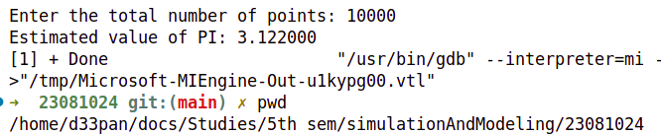

Conclusion:
The experiment successfully demonstrated the application of the Monte Carlo Simulation to estimate the value of π. As the number of randomly generated points increased, the estimated value of π became closer to its actual value, validating the law of large numbers. This method, although simple, provided an effective approximation of π and illustrated how probabilistic simulations can be used for numerical estimation. Overall, the experiment emphasized the power of randomized methods in solving complex problems and the importance of simulation in various fields of study.

